PCB design

This document will show the pcb, discuss what everything on it is and how it should be configured.

Before reading this document we suggest reading document P003 and having a quick look at D001.

We will start with the overview of the pcb, followed by what each component is. Then we will look at the schematic version and discuss the connections.

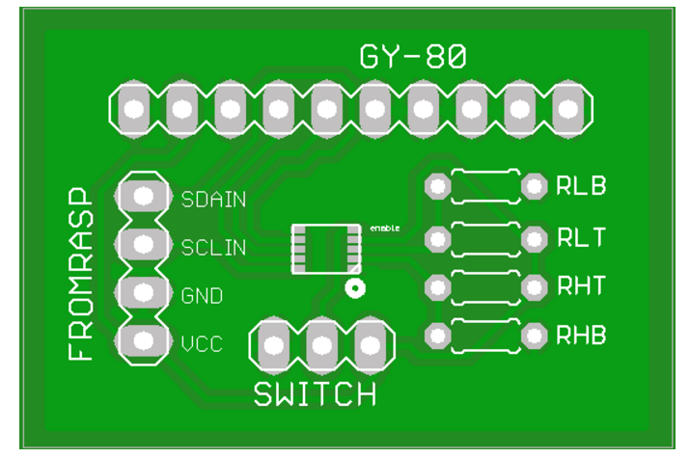Below is a top down view of the pcb.

The board has 3 headers, 4 resistors and a chip.

The chip is the LTC4316 [D001]. This chip is orientated up side down on this view. The circle on the whitescreen is to indicate the pin1.

As discussed in the document [P003] this chip uses voltage inputs in order to set an XOR byte to convert the I2C bus on.

The resistors are marked in the same way as they are on page 9 figure 5 of the D001 document.

By setting these resistors you can change what I2C XOR byte you will set, correct values for your XOR byte can be found in the datasheet [D001].

Then we will discuss the headers:

The GY-80 header is designed to have a GY 80 hooked up directly to it (using a male header strip will allow for enough clearance to have the GY-80 directly on top of this PCB).

The left most pin of this header (in the orientation as shown above) is the 5V line from the GY-80. The PCB is designed to have all the connections from the GY-80 connected to it in order to allow for a strong connection on the GY-80 and in order to help our group figure out where on the pcb we could place the Gy-80.

The connection to the raspberry can be made directly with wires or 90 degree headers could be used to allow plugging in multiple devices easily.

The wires connecting to this terminal can be connected to other PCB's as well (That's the whole point of this PCB).

The last header is a switch header. The idea behind this is to have a jumper connecting the middle pin to either the ground (left) or the power (right).

This is connected to the enable pin (pin 5 in D001). By hooking this up to the GND and then the VCC it allows the user to reset the pcb. This has to be done if resistor values are changed.

In the following section we will briefly go over the schematic of the PCB [P004].

In this schematic the LTC4316 is in the middle. The voltage dividers mentioned on page 9 of [D001] can be found on the left side of the diagram.

The reset switch is below and to the left of the LTC chip. Both headers can be found on the right side.

The headers both have a clock and data signal. The GY-80 header uses the output signals and the Raspberry header has the input signals.

The PCB has been ordered via Seeedstudio ([www.seeedstudio.com](http://www.seeedstudio.com/)) (yes that third e is not a typo).